Curriculum Vitae
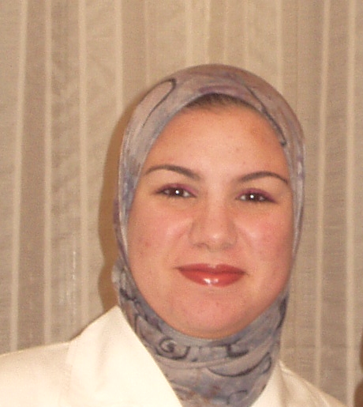

Name: Nivin Abdel-Azim Abdel-Rehim Hassan

Sex: Female

Nationality: Egyptian

Date of Birth: 27th November,1979

Place of Birth: Assiut, Egypt

Marital Status: Married

Education:
Graduate of Salam Language School
Bachelor of Pharmaceutical Sciences, Assiut University, Egypt, May 2002
(Very Good)

Further Education:
MSc Degree in Clinical Pharmacy (Pharmaceutics Department),Faculty of Pharmacy, Assiut University, Assiut, Egypt, October 2006

Positions Held:
›Clinical Pharmacist in South Egypt Cancer Institute, Assiut University
(01/10/2002-25/10/2010)
›Assistant Lecturer in Pharmacology and Experimental Chemotherapy Unit, Cancer Biology Department, South Egypt Cancer Institute, Assiut University (26/10/2010- till now)

Field Experience & Community Work:
› Working experience in commercial pharmacies for 5 months
› Training course in basic cGMP in T3A Factory, Assiut (08/07/2001-12/07/2001)
› Training course in clinical pharmacy department (Adult Unit) of the National Cancer Institute (NCI), Cairo University (04/05/2003-04/06/2003)
› The first training course in clinical pharmacy, Pharmaceutics Department, Faculty of Pharmacy, Assiut University (June 28-30/2005)
› One-day course titled "New Drug Update & Adverse Drug Reactions Reporting" in Misr International University, Cairo, Egypt in collaboration with University of Georgia, USA

› Training course in clinical pharmacy departments (Pediatric and Adult units) of the National Cancer Institute (NCI), Cairo University (08/01/2007-15/1/2007)
› Training course in clinical aspects for pharmacists, International Cultural Center, Medical Education Department, Cairo (01/07/2007-19/07/2007)
› Workshop on ″Laboratory Biosafety & its Levels″, Molecular Biology Research Unit, Assiut University (27/12/2009-28/12/2009)
› Workshop entitled "Isolation, Proliferation & Differentiation of Human Cord Blood Stem Cells along Hepatocyte Lineage", The Holding Company for Biological Products and Vaccines, Cairo (19-21 June 2010)
› Workshop entitled "Recent Advances of Pathology Services in Cancer Management"-CME 10 Credit Points, South Egypt Cancer Institute, Assiut University (21 October 2010)

Scientific Interests:
Main preference is clinical pharmaceutical studies in chemotherapeutic agents

Scientific Meetings:
› Member of the organizing committee of the Faculty of Pharmacy 4th EPSF Congress (1999)
› Attending the XXVIII conference of Pharmaceutical Sciences, Cairo (17-19 December 2002)
› Attending the 5th annual conference of Assiut University Pharmacists, Assiut (16-17 April 2003)
› Participation in the clinical pharmacy workshop as the scientific activities of the 6th pharmaceutical conference of Assiut University Hospitals Pharmacists (20-22 March 2004)
› Participation in the clinical pharmacy training program as a co-operative scientific activities of Faculty of Pharmacy, El Azhar University, Assiut (14th April - 5th May 2005)
› Participation in the Second Scientific Conference of South Egypt Cancer Institute, Assiut University (3-6 April, 2007)
› Attending the 8th International Thalassemia Conference, Cairo (9-10 May, 2007)
› Attending the Children′s Cancer Hospital Egypt 57357 Scientific Conference 2009, Cairo (5-11 July, 2009)
› Attending the 1st Annual Scientific Conference of the Clinical & Chemical Pathology Department , Cairo University (31 March-2 April, 2010)
› Attending the 19th Annual Conference of Kasr El-Aini Center of Clinical Oncology & Nuclear Medicine, Cairo University (29 September-1 October 2010)
› Attending the Joint International Conference of NCI Egypt, EORTC and MMOF (Lung and Breast Cancer), Cairo (29-31 October 2010)
› Member of the Pharmaceutical Society of Egypt

Foreign Languages:
English (Advanced) Tofel score: 537
French (Advanced)
German (Grundstufe I)

●Good Computer Skills

Traveling Experience:
University leisure trip to Syria, 1998

Address:
30 Ali Allouba Street,
Assiut, 11117
Egypt
Telephone:
Mobile 0123971304
Home 0882323513

